Underground Tunnel Trophy: McMackins' $85 Million Manalapan Estate Dominates Palm Beach Deals
By Alec Novak
Published on May 27, 2026
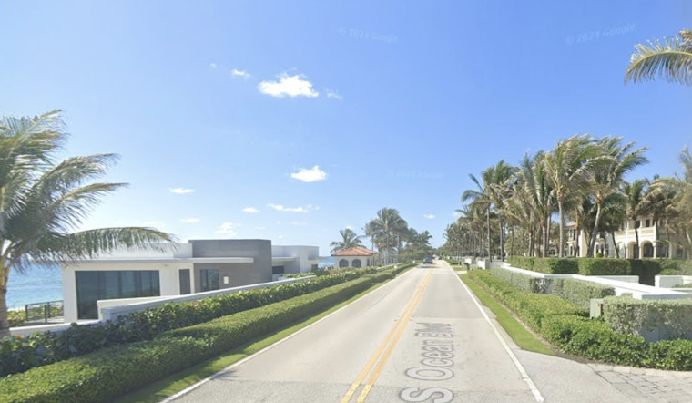

Source: Google Street View
The McMackins' ocean-to-lake compound in Manalapan, listed at $85 million, just took the crown as Palm Beach County’s priciest signed contract of the week. Between May 18 and May 24, buyers inked 15 luxury deals totaling about $210 million, with the lake-to-ocean estate at 1660 South Ocean Boulevard leading the charge. The headline feature: a private underground tunnel that links the main house to an air-conditioned beach bungalow. The spree highlights that demand at the very top of the Palm Beach market is still running hot.
Palm Beach contracts this week
As reported in Douglas Elliman’s weekly Eklund-Gomes report, buyers signed 15 contracts between May 18 and May 24 totaling roughly $210 million. The breakdown: 10 single-family homes and five condos went under contract, and the week’s pending properties averaged about 134 days on the market before finding takers.
What’s listed at 1660 South Ocean
The ocean-to-lake compound at 1660 South Ocean Boulevard is listed for $85 million with Margit Brandt of Premier Estate Properties. Listing details describe a roughly 2.06-acre lot with about 165 feet of water frontage, multiple guest suites, an eight-car garage, a wellness wing and a private tunnel to a beach bungalow, and credit builder RWB Construction plus Benedict Bullock Group and Marc-Michaels for the design and interiors, according to the broker’s listing at Premier Estate Properties.
Owners and price history
Cindy and Ron McMackin, the owners of Pan-Pacific Mechanical, purchased the ocean-to-lake parcel in late 2020 for roughly $38.9 million, according to property records at PropertyPanorama. The Real Deal reports the McMackins listed the seven-bedroom compound with Margit Brandt, and the property’s pending status made it the most expensive contract in the county that week.
Market takeaways
The Eklund-Gomes weekly report shows single-family homes that went pending averaged about $17.8 million and roughly $1,816 per square foot, while condos averaged about $5.8 million and $2,208 per square foot, with condos spending longer on the market, according to the Eklund-Gomes report. That split points to strong buyer demand for turnkey waterfront single-family product even as high-end condo inventory lingers.
If the pending deal closes at or near asking, the McMackins would realize a sizable paper gain over their 2020 purchase. For trophy sellers in Manalapan, the week’s activity is a pointed reminder that deep-pocketed buyers are still willing to pay up for move-in-ready coastal compounds.

